Project 2: Hypothesis Test and Regression Analysis
FIN 6307.501 - Mathematical Methods for Finance - F25

By Group 6
Priyadarshan Parida (PXP230068)
Sunayana Jana (SXJ230076)

Table of Contents
1. Introduction 3
2. Industry Sector, Stock, and Analysis Framework Selection 3
3. Data Collection and Exploratory Analysis 6
(a) Descriptive Analytics of Stock Returns 6
(b) Covariance and Correlation Analysis 9
(c) Stock Returns and Financial Fundamentals Relationship Analysis 10
(d) Equal-weighted Portfolio Construction & Performance Analysis 12
(e) Optimal Portfolio Analysis Construction & Performance Analysis 13
4. Conclusion 15
References 16
Appendix 17

1. Introduction
This project builds on the analysis completed in Project 1 by taking a deeper look at how the two portfolios behave across key risk and return measures. We compare the portfolios using their daily return patterns, which allows us to evaluate differences in volatility, average performance, and overall risk behavior in a more detailed and consistent way. This helps reinforce or challenge the conclusions formed earlier about how these portfolios differ under normal market conditions.
Another goal of the project is to estimate betas for the individual companies included in our earlier analysis. Publicly available betas often use different assumptions, time windows, and market benchmarks, which may not match our specific context. By computing betas ourselves, using a clear and consistent modeling approach, we gain results that better fit our specific analysis and allow us to assess the adequacy of these models for portfolio comparison.

2. Industry Sector, Stock, and Analysis Framework Selection
Step 1: Economic Factor as the Research Theme
- ChatGPT Prompt: Select two industry sectors for my Finance Project. Help me decide which economic factor to base the selection on. I am considering “Monetary Policy”. Walk me through the pros and cons.
- Response Summary and Decision (based on research on ChatGPT and other forums): The project will focus on Interest Rate / Monetary Policy Changes as the core economic factor since rate fluctuations directly influence borrowing costs, corporate valuations, and portfolio returns. This aligns well with the project objectives involving risk and return analysis.
Step 2: Defining the Economic Factor and Research Theme
- ChatGPT Prompt: List two industry sectors that are most sensitive to changes in interest rates. Explain briefly how rising or falling rates impact each sector’s profitability and stock performance.
- Response Summary and Decision (based on research on ChatGPT and other forums): The selected sectors for the project are Financials and Real Estate. Both are influenced by changes in monetary policy but react differently. We expect the analysis to provide a clear contrast for analyzing how interest-rate movements affect risk and return.
Step 3: Stock Selection Criteria
- ChatGPT Prompt: What are some of the criteria, such as market cap/earnings stability/gross margin, that can be used to choose stocks within each sector?
- Response Summary and Decision (based on research on ChatGPT and other forums): The project will base stock selection on a combination of market size, stability, profitability, leverage, valuation, and data availability. These criteria ensure that each chosen company accurately represents its sector’s exposure to interest-rate changes and provides high-quality data for return and risk analysis.
Category | Criteria | Purpose / Relevance
Market & Size Metrics | Market Capitalization / Liquidity | Ensures large, actively traded firms with reliable data and minimal noise.
Financial Performance & Stability | Earnings Stability / Revenue Consistency / Gross & Net Margins / ROE | Identifies companies with steady profitability under changing rate environments.
Leverage & Capital Structure | Debt-to-Equity Ratio / Interest Coverage | Captures sensitivity to borrowing costs and balance-sheet strength.
Valuation & Income Metrics | P/E Ratio / Dividend Yield / Beta | Indicates how investors price risk and income potential relative to Treasury yields.
Sector-Specific Indicators | Net Interest Margin (Banks) / Funds from Operations (REITs) | Measures core profitability drivers specific to Financials and Real Estate.
Data Quality & Availability | Historical coverage on Nasdaq & Capital IQ (5-year window) | Ensures consistency and completeness of return and fundamental data.

Step 4: Stock Selection and Company Introduction
- ChatGPT Prompt: Can we explore representative stocks, five each, from the Financials and Real Estate sectors, that are most sensitive to interest-rate changes? Use the criteria we discussed earlier, including market capitalization, earnings stability, and leverage.
- Response Summary and Decision (based on research on ChatGPT and other forums):
Sector | Company | Ticker | Introduction
Financials | JPMorgan Chase & Co. | JPM | Leading U.S. bank; large balance sheet sensitive to rate spreads.
Financials | Bank of America Corp. | BAC | Retail and commercial exposure; strong net-interest income growth.
Financials | Wells Fargo & Co. | WFC | Major mortgage lender; affected by consumer-rate changes.
Financials | Goldman Sachs Group Inc. | GS | Investment bank: earnings tied to market and policy cycles.
Financials | BlackRock Inc. | BLK | Global asset manager; reflects investor flows responding to rate expectations.
Real Estate | Prologis Inc. | PLD | Industrial/logistics REIT; valuations linked to financing costs.
Real Estate | American Tower Corp. | AMT | Telecom infrastructure REIT; capital-intensive, debt-sensitive model.
Real Estate | Simon Property Group Inc. | SPG | Retail REIT. Interest rates influence consumer activity and property values.
Real Estate | AvalonBay Communities Inc. | AVB | Residential REIT. Higher mortgage rates shift demand toward rentals.
Real Estate | Realty Income Corp. | O | High-dividend REIT. Performance tracks Treasury yields closely.

Step 5: Framework
- ChatGPT Prompt: We want to perform descriptive analytics that address risk, return, and portfolio performance over five years. What financial measures can be included in the analysis framework to evaluate the selected companies? Consider the influence of the chosen economic factor – “monetary policy”.
- Response Summary and Decision (based on research on ChatGPT and other forums):
Category | Metric / Field Name (Capital IQ) | Purpose / Reason for Inclusion
Market & Size Metrics | Market Capitalization (Latest – USD millions) | Indicates company size and investor valuation; useful for cross-sector comparison.
Market & Size Metrics | Revenue (USD millions, Latest Annual) | Measures overall business scale and growth potential.
Profitability & Efficiency | Return on Equity (ROE) % – Latest Annual | Core profitability indicator; captures how efficiently equity is deployed.
Profitability & Efficiency | Gross Margin % – Latest Annual | Assesses production efficiency and cost control.
Profitability & Efficiency | Net Margin % – Latest Annual | Indicates overall profitability after all expenses.
Profitability & Efficiency | EBITDA Margin % – Latest Annual | Captures operating profitability before financing costs; rate-sensitive for leveraged firms.
Leverage & Capital Structure | Debt to Equity Ratio % – Latest Annual | Measures financial leverage; high ratios signal stronger exposure to rate increases.
Leverage & Capital Structure | Total Debt (USD millions, Latest) | Complements the ratio by showing absolute borrowing levels.
Leverage & Capital Structure | Total Assets (USD millions, Latest) | Provides firm size and helps contextualize leverage.
Valuation & Market Perception | Price to Earnings (P/E) Ratio – Latest | Reflects investor valuation expectations and market sentiment.
Valuation & Market Perception | Dividend Yield % – Latest | Allows comparison between income returns and Treasury yields.
Optional Efficiency Enhancers (if available) | Return on Assets (ROA) % – Latest Annual | Offers asset-based profitability perspective, balancing ROE for leveraged firms.
Optional Efficiency Enhancers (if available) | Interest Coverage Ratio – Latest Annual | Shows capacity to meet interest obligations, especially for REITs.

3. Data Collection and Exploratory Analysis
Adjusted-close data was downloaded from NASDAQ for each of the ten selected companies. The S&P 500 Index was taken from the S&P database provided through Yahoo Finance API and used for comparative and correlation analysis. The 13-week U.S. Treasury Bill yield was taken from Federal Reserve Economic Data (FRED) provided through Yahoo Finance API, used for Sharpe-ratio calculations. Financial metrics (e.g., ROE, Debt-to-Equity, Market Cap, P/E Ratio) were exported from S&P Capital IQ Pro to link stock performance to fundamentals.

(a) Descriptive Analytics of Stock Returns
Weekly log returns (Friday close) were computed for ten companies using adjusted-close prices from Oct 2020 to Oct 2025. For each stock $i$, let $P_{i,t}$denote its adjusted closing price at week t.
$$R_{i,t}​=ln\left(\frac{​P_{i,t}}{P_{i,t-1}}​\right)$$
The empirical histograms of $R_{i,t}$ were overlaid with a normal distribution to visually assess deviations of returns from normality.
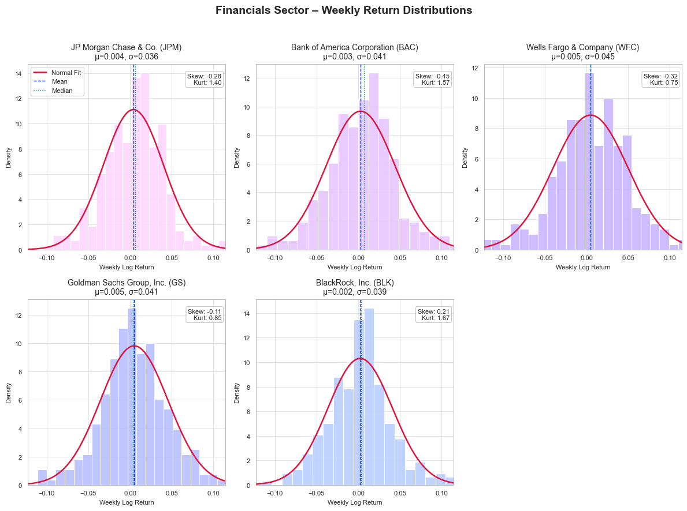
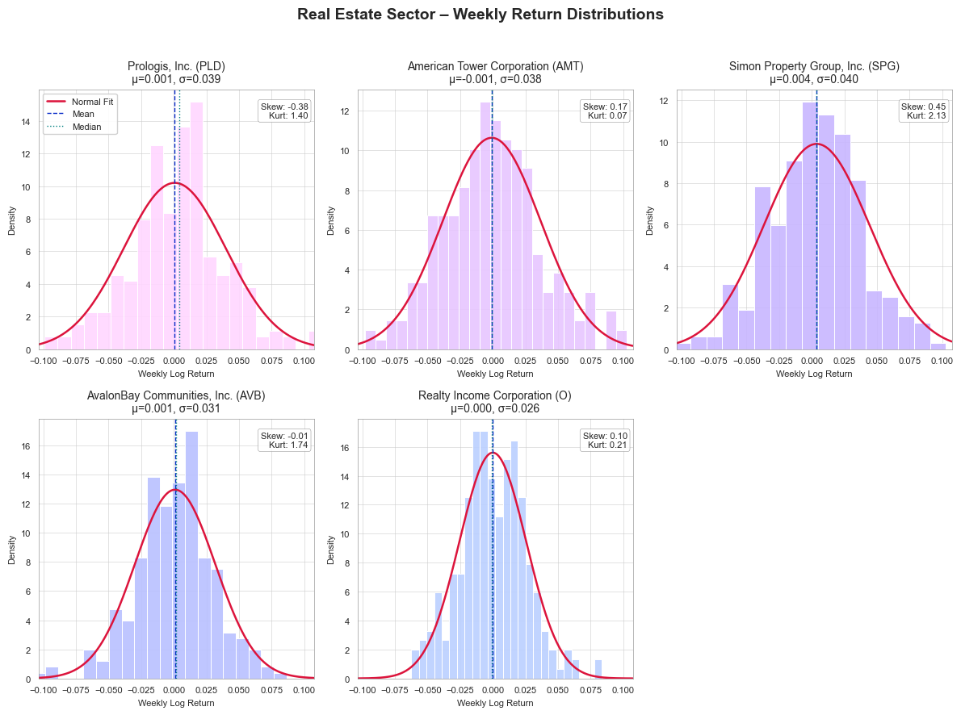
Fig 1: Normality of Stock Returns
Performance of each stock over 5 years:
Ticker | Mean | Median | StdDev | Skewness | Kurtosis
JPM | 0.0041 | 0.0064 | 0.0359 | -0.2812 | 1.4033
BAC | 0.0028 | 0.0069 | 0.0413 | -0.4461 | 1.5747
WFC | 0.0049 | 0.0046 | 0.045 | -0.3231 | 0.7536
GS | 0.005 | 0.0036 | 0.0406 | -0.11 | 0.8485
BLK | 0.0023 | 0.0037 | 0.0387 | 0.2088 | 1.6726
PLD | 0.0007 | 0.0042 | 0.0391 | -0.3784 | 1.4013
AMT | -0.0008 | -0.001 | 0.0375 | 0.1663 | 0.068
SPG | 0.0038 | 0.0033 | 0.0403 | 0.4535 | 2.1311
AVB | 0.001 | 0.0017 | 0.0308 | -0.0143 | 1.7356
O | 0 | -0.0006 | 0.0256 | 0.1023 | 0.2108

Summary by sector:
Sector | Tickers | Mean | Standard Deviation | Typical Skew | Typical Kurtosis | Notes
Financials | JPM, BAC, WFC, GS, BLK | 0.002 – 0.005 | 0.036 – 0.045 | Slightly negative (-0.1 to -0.45) | 0.8 – 1.7 | Light tails, mild left-skew → modest downside asymmetry
Real Estate | PLD, AMT, SPG, AVB, O | −0.001 – 0.004 | 0.026 – 0.040 | Mostly near zero (-0.4 to +0.4) | 0.1 – 2.1 | Generally symmetric; SPG exhibits heavier tails

Key Findings - Financials:
- Return distributions appear approximately bell-shaped but slightly left-skewed, indicating occasional larger negative weeks.
- Kurtosis values < 3 imply flatter-than-normal (platykurtic) profiles – less tail risk relative to a true normal.
- Among these, Goldman Sachs (GS) and BlackRock (BLK) are closest to normality, whereas BAC and WFC show more asymmetry.
Key Findings - Real Estate:
- Returns are narrower and more symmetric than financials, consistent with lower volatility.
- SPG (Simon Property Group) shows mild right-skew and higher kurtosis, suggesting sporadic positive jumps, while Realty Income (O) is nearly symmetric and the least volatile.
Inter-Sector Comparison
Aspect | Financials | Real Estate
Average weekly return | Slightly higher (≈ 0.4–0.5%) | Lower (≈ 0.1–0.2%)
Volatility | Higher (σ ≈ 4 %) | Lower (σ ≈ 3 %)
Normality | Mildly non-normal (left-skewed) | Closer to normal, lighter tails
Implication | More responsive to macro & rate shocks | More stable, income-driven profiles

Overall, weekly log returns for both sectors are approximately symmetric with light tails, though financials display higher volatility and slight negative skewness. This suggests greater downside sensitivity to interest-rate or policy shifts, while real-estate equities show smoother, yield-driven performance.
The observed distributions justify further cross-sector regression or beta analysis in Step 2, using step1_returns.csv as the common input dataset.

(b) Covariance and Correlation Analysis
Weekly log returns for the ten selected companies were analyzed alongside the S&P 500 index over the same period. The data were aligned by date to ensure consistency and used to construct both covariance and correlation matrices. These matrices are used to capture how closely returns move together and the extent to which each stock’s risk interacts with others in the portfolio. The resulting statistics and visualizations provide a basis for assessing intra-sector, cross-sector, and market-wide relationships in preparation for portfolio-level risk evaluation.
Key Findings:
- Intra-Financial Correlation ≈ 0.75:
  - Indicates very strong co-movement among financial sector stocks (JPM, BAC, WFC, GS, BLK).
  - Suggests limited diversification within the sector—banks and asset managers respond similarly to interest-rate or credit-spread shifts.
- Intra-Real Estate (REIT) Correlation ≈ 0.54:
  - Moderate co-movement across Real Estate firms (PLD, AMT, SPG, AVB, O).
  - Reflects that REITs share exposure to financing costs but differ in property focus and leverage profiles.
- Cross-Sector (Financial ↔ Real Estate) Correlation ≈ 0.41:
  - Lower than within-sector averages, showing meaningful though not perfect diversification when combining the two sectors.
  - Portfolio risk can be reduced slightly by holding both groups together.
- Relationship with S&P 500 (Index Ticker SP500_ret):
  - Highest correlation: BLK (≈ 0.51) — diversified global asset manager tracking market performance closely.
  - Moderate correlations (≈ 0.42–0.44): JPM, BAC, GS, AVB — large firms whose earnings move with macro trends.
  - Lower correlations (< 0.40): O, PLD, SPG, WFC, AMT — offer partial diversification versus the broad equity market.
- Overall pattern:
  - Financials exhibit stronger interconnected risk; Real Estate provides moderate diversification.
  - Both sectors are positively correlated with the S&P 500, confirming general market dependence but also highlighting that certain REITs (notably AMT) can cushion market volatility.
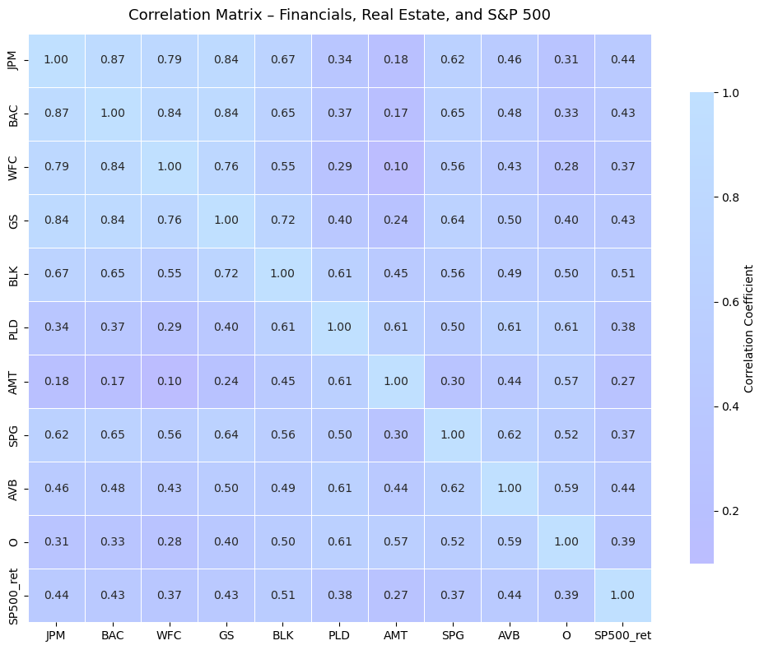
Fig 2: The Correlation Heatmap

(c) Stock Returns and Financial Fundamentals Relationship Analysis
While this step primarily examines the relationship between stock returns and financial fundamentals, we also extend the analysis to include volatility to better understand the risk dimension of those same fundamentals. By merging each company’s average return and volatility (from the previous steps) with fundamental metrics from Capital IQ (such as ROE, leverage, valuation, and dividend yield), we examined how firm characteristics relate to performance and stability.
Key Findings:
- Leverage (Debt-to-Equity) shows the strongest association with both higher returns and higher volatility, confirming that debt amplifies risk exposure.
- Profitability metrics (ROE, EBIT/Interest) relate positively but moderately to returns, suggesting efficient firms earn higher returns without proportionate increases in risk.
- High-dividend and high-valuation stocks deliver lower returns and lower volatility, typical of mature, defensive firms.
- Extended volatility-based plots illustrate that leverage and firm size are primary drivers of risk sensitivity within and across sectors.
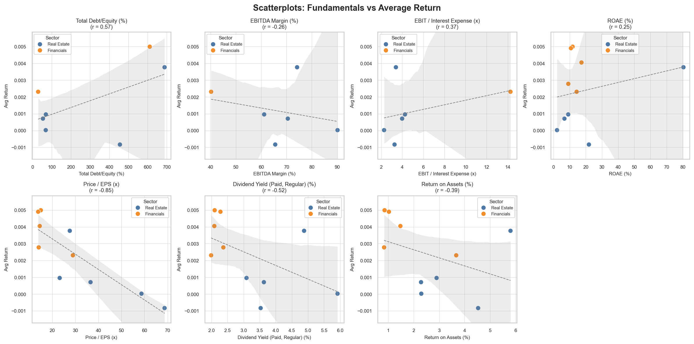
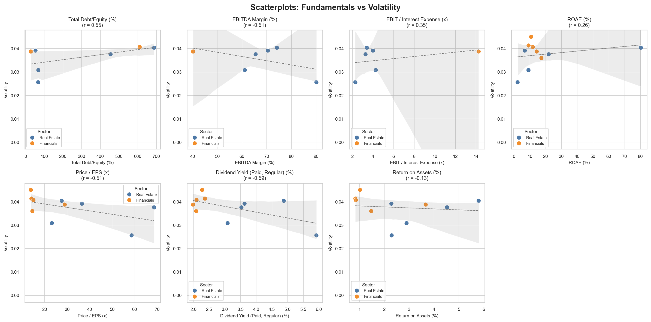
Fig 3: Scatterplots - Stock returns vs financial fundamentals
Note: During the data merge with Capital IQ fundamentals, several variables contained missing or null values (e.g., Gross Margin %, Net Margin %, EBITDA Margin %, and Interest Coverage Ratio).
- These are not data-quality issues but stem from sector-specific accounting conventions.
Banks and diversified financial institutions (JPM, BAC, WFC, GS, BLK) report net interest income rather than cost-of-goods-based margins and therefore do not disclose gross or operating margins in a comparable format.
- Similarly, interest coverage ratios are not meaningful for banks because interest expense is a function of their core lending business, whereas for Real Estate Investment Trusts (REITs), such ratios reflect debt-service capacity. Consequently, these fields appear as “N/A” for financial institutions but are valid for REITs.
- This distinction highlights inherent differences in financial statement structures across sectors. Hence, the cross-sector fundamental analysis focused on comparable metrics such as ROE, Debt-to-Equity, Market Capitalization, and Dividend Yield.

(d) Equal-weighted Portfolio Construction & Performance Analysis
This step constructs an equal-weighted portfolio of ten selected stocks (Financial: JPM, BAC, WFC, GS, BLK, and Real Estate: PLD, AMT, SPG, AVB, O) to evaluate its performance relative to the market benchmark (S&P 500) under the influence of monetary-policy changes.
- An equal-weighted portfolio was formed by assigning identical weights of 10% to each stock (log returns for each stock $R_{i}(t)$ were taken from the output of part (a) return analysis).
$$R_{p}\left(t\right)=\sum_{i=1}^{10}{{w_{i}×R}_{i}(t)}=\sum_{i=1}^{10}{{\frac{1}{10}×R}_{i}(t)}$$
- The weekly mean return (${\overset{ˉ}{R}}_{p}$), volatility ($σ_{p}$), and Sharpe ratio were computed as:
$$Sharpe {Ratio}_{p}​=\frac{\overline{R}​_{p}-r_{f}​​}{σ_{p}}$$
- $r_{f}$ is the weekly risk-free rate derived from the 13-Week T-Bill yield (annualized % yield):
$$r_{f}​={\left(1+\frac{Y_{TBill}}{100}​​\right)}^{\frac{1}{52}}-1$$
- All data series were aligned on a typical weekly frequency (Friday close). The portfolio’s average weekly return was similar to that of the S&P 500, but its volatility was higher due to concentration in two rate-sensitive sectors. Consequently, its Sharpe ratio was slightly lower than the market’s.
Metric | Portfolio | S&P 500
Mean Weekly Return | 0.00259 (0.26 %) | 0.00275 (0.27 %)
Weekly Volatility (σ) | 0.02818 (2.82 %) | 0.02284 (2.28 %)
Sharpe Ratio (weekly) | 0.071 | 0.095
Annualized Return | 13.48 % | 14.29 %
Annualized Volatility | 20.32 % | 16.47 %
Annualized Sharpe | 0.51 | 0.68

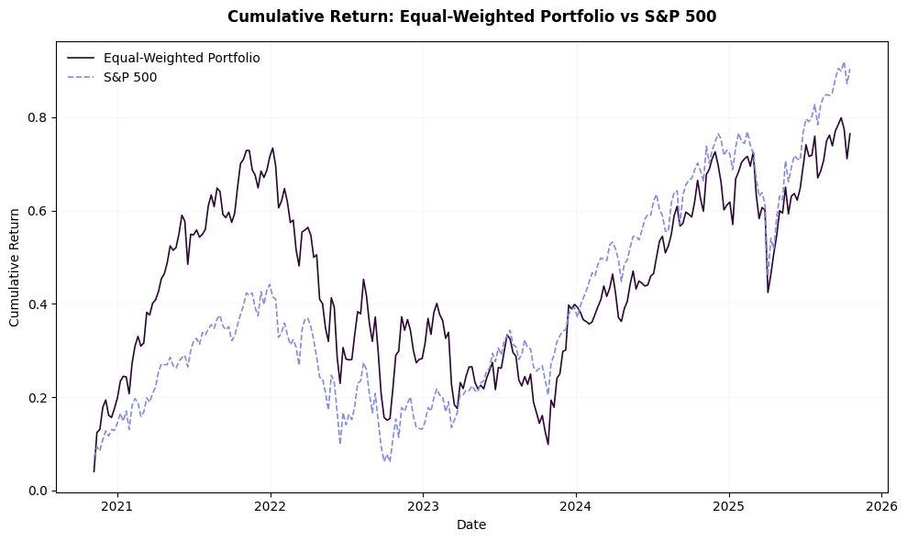
Fig 4: Cumulative Returns from Equal-Weighted Portfolio vs S&P 500
- Cumulative-return comparison (Figure 4-1) shows that while the portfolio generally tracks the S&P 500’s trend, its smaller sectoral diversification led to greater fluctuations during rate-policy shifts.
- The portfolio achieved comparable returns but with ~20 % higher volatility than the benchmark.
- Sharpe ratio (0.51 vs 0.68) indicates the market delivered better risk-adjusted performance.
- As established in part (b), the average intra-financial sector correlation was ≈ 0.75, intra-Real Estate ≈ 0.54, and cross-sector ≈ 0.41. Cross-sector diversification helped partially offset intra-sector correlation but did not fully match the S&P 500’s broad diversification benefit.

(e) Optimal Portfolio Analysis Construction & Performance Analysis
In this step, the ten-stock portfolio was optimized to maximize the Sharpe ratio, yielding the tangency portfolio on the efficient frontier. The optimization problem was formulated as:
$$\max_{w}{ \frac{w^{T}μ-r_{f}}{\sqrt{σ_{p}}}} s.t. \sum_{i}{w_{i}=1, w_{i}≥0}$$
$$σ_{p}=w^{T}×Ω×w$$
Where $w$ is the weight vector, $μ$ the vector of expected weekly returns. The numerator represents the portfolio’s expected excess return over the risk-free rate, while the denominator represents total portfolio volatility $σ_{p}$. $Ω$ is the covariance matrix of stock returns.
The optimal long-only weight vector was computed using Python libraries. The optimal portfolio turned out to be dominated by GS (65.6%), WFC (23.3%), and SPG (10.6%), producing an expected weekly return of 0.00484, volatility 0.0383, and Sharpe 0.111.
Portfolio | Top Holdings / Weights | Mean Weekly Return | Weekly Volatility | Sharpe Ratio
Optimal (Tangency) | GS 65.6%, WFC 23.3%, SPG 10.6% | 0.00484 | 0.0383 | 0.111
Equal-Weighted (Step 4) | 10 stocks @ 10 % each | 0.00259 | 0.0282 | 0.071
S&P 500 Benchmark | Market Index | 0.00060 | 0.0108 | 0.001

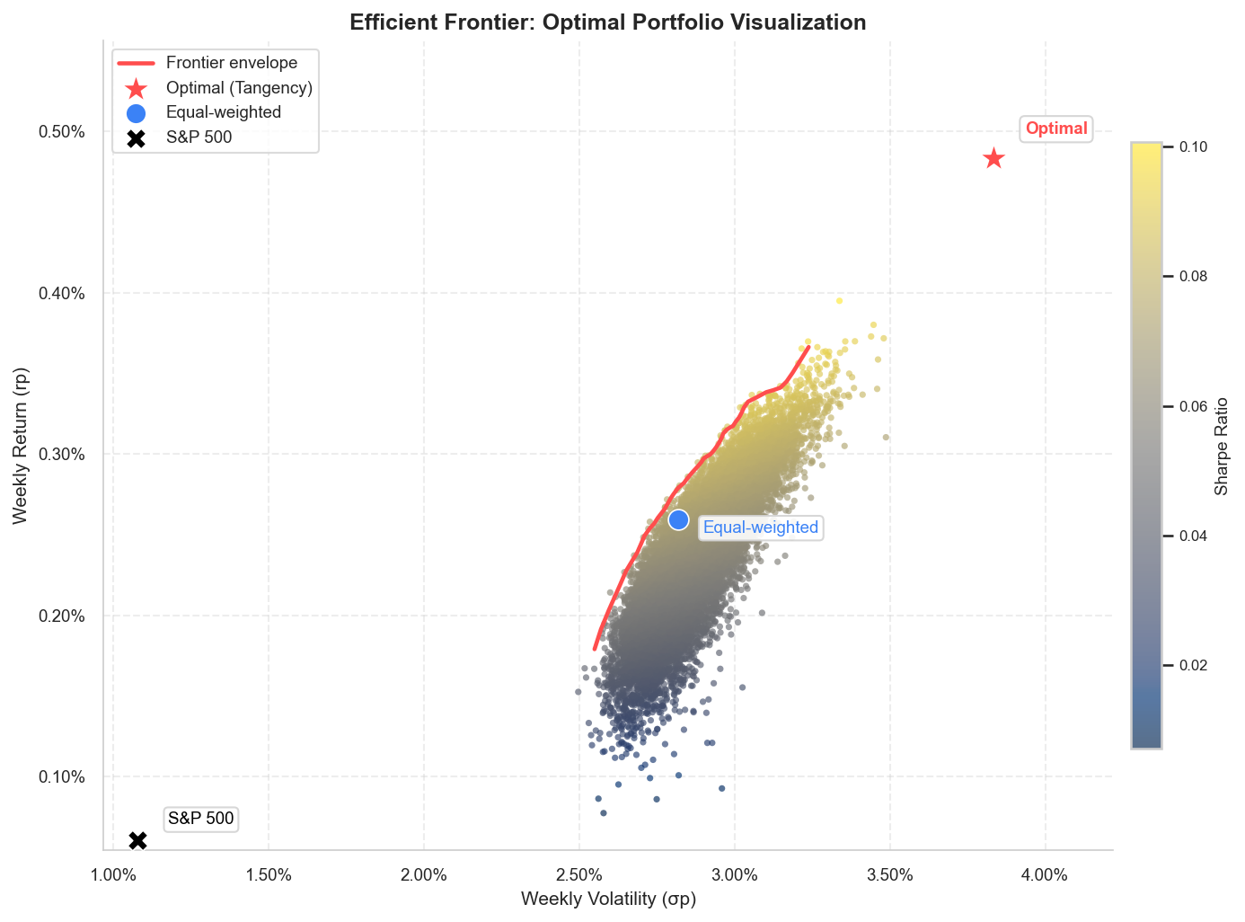
Fig 5: Efficient Frontier – Optimal Portfolio Visualization
When compared with the equal-weighted portfolio from Step 4 (return 0.00259, volatility 0.0282, Sharpe 0.0713) and the S&P 500 benchmark (return 0.0006, volatility 0.0108, Sharpe 0.0013), the optimized portfolio demonstrates a clear efficiency improvement, achieving a higher return per unit of risk. The efficient-frontier plot highlights this improvement: the optimal portfolio (★) lies on the upper boundary, the equal-weighted portfolio (●) lies below it, and the S&P 500 (×) occupies the lower-left region.

4. Conclusion
This project examined the impact of monetary policy changes exhibited through interest-rate movements on the performance and risk characteristics of two interest-sensitive sectors: Financial institutions and Real Estate companies. By analyzing five years of market and firm-level data, the study combined return-distribution analytics, cross-sector correlations, and portfolio modeling to assess the influence of rate fluctuations on individual stocks and how portfolio diversification can mitigate the impact. The analysis used the 13-Week U.S. Treasury Bill yield as the risk-free rate and incorporated both equal-weighted and optimized portfolio designs to evaluate efficiency and diversification outcomes.
The results revealed clear sector-wise differences in both performance and risk. Financial stocks, particularly large banks and asset managers such as JPMorgan, Bank of America, and BlackRock, exhibited higher volatility but also stronger mean returns, consistent with their positive sensitivity to rising interest rates. Real Estate Investment Trusts (REITs) such as Prologis, AvalonBay, and Realty Income demonstrated steadier but lower returns, reflecting their dependence on borrowing costs. Correlation analysis confirmed higher intra-sector cohesion among Financials compared with Real Estate, while cross-sector correlations remained moderate, indicating the diversification potential between the two sectors.
Portfolio analysis demonstrated that diversification across these sectors improved overall efficiency. The equal-weighted portfolio delivered balanced exposure with a moderate Sharpe ratio, while the optimized (tangency) portfolio achieved a higher risk-adjusted return by slightly increasing weight toward Financials and lower-volatility REITs. Overall, the findings support the conclusion that interest-rate dynamics significantly influence sectoral risk and return behavior, and that informed portfolio construction can mitigate rate-driven volatility while enhancing performance.

References
- ChatGPT.com Exploration & Research on https://chatgpt.com/
- NASDAQ Data Link. Historical stock prices for JPM, BAC, WFC, GS, BLK, PLD, AMT, SPG, AVB, and O. Retrieved from https://data.nasdaq.com/
- Yahoo Finance. S&P 500 Index (^GSPC) – Historical Data. Retrieved from https://finance.yahoo.com/quote/%5EGSPC/history
- Federal Reserve Bank of St. Louis (FRED) and Yahoo Finance. 13-Week Treasury Bill: Secondary Market Rate (DGS3MO). Retrieved from Yahoo API.
- S&P Capital IQ Pro. Company financials and market fundamentals for selected firms. Retrieved via institutional access (The University of Texas at Dallas).
- BlackRock, Inc. Annual Report and Investor Relations Data. Retrieved from https://www.blackrock.com/corporate/investor-relations
- Prologis, Inc. Investor Relations – Company Overview and Financial Reports. Retrieved from https://ir.prologis.com/
- AvalonBay Communities, Inc. Investor Relations – Company Financials. Retrieved from https://investors.avalonbay.com/
- U.S. Securities and Exchange Commission (SEC). EDGAR Company Filings. Retrieved from https://www.sec.gov/edgar/searchedgar/companysearch.html
- Investopedia. Sharpe Ratio, Portfolio Diversification, and Modern Portfolio Theory. Retrieved from https://www.investopedia.com/
- Hull, J. C. Options, Futures, and Other Derivatives (10th ed.). Pearson Education. (Reference for risk/return and Sharpe ratio concepts.)

Appendix
- See “Group6_Project1_FIN 6307.501.xlsx” for tabular outputs
- See “Group6_Project1_FIN 6307.50_Code.pdf” for code review
- See “Group6_Project1_FIN 6307.50_CodePackage.zip” for complete code and input files packaged together

